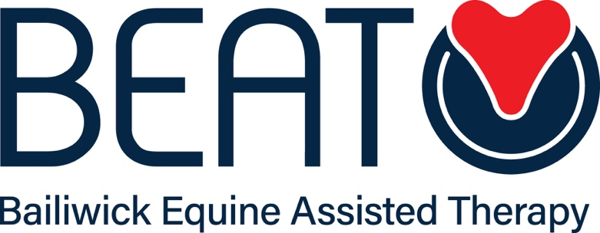

Safeguarding Children and Young People

Policy and Procedures

Name of Organisation: BEAT Limited (BEAT)

Venue Address for which policy applies: All venues
Date of last review: 5th January 2021
Date of next review: 5th January 2022
Name of Author: Claire Cole

- introduction

  - This policy seeks to:

    - Explain signs and indicators that are relevant to responsibilities of safeguarding;

    - Provide clear guidance on who should be considered as an at risk child or young person; and

    - Provide clear guidance on what should be done by BEAT and its directors, staff and volunteers as regards safeguarding.
- OBJECTIVES

  - BEAT is committed to safeguarding and protecting the welfare of all who use its service and recognises its responsibilities to protect the welfare of children and young people from harm whilst using its services.

  - BEAT is committed to high standards of practice in safeguarding the welfare of children and young people.

  - BEAT has no statutory remit or role to investigate abuse but acknowledges a responsibility to pass on to the appropriate statutory agency concerns in relation to the safety or welfare of any individual using its services so that these concerns can be appropriately assessed.

  - BEAT’s safeguarding policy aims to achieve the following three objectives by being vigilant in the execution of our duties:

    - Creating a culture where children and young people are valued and their right to safety and respect is upheld.

    - Actively managing risk to minimise circumstances where children or young people may suffer harm.

    - Making referrals to other organisations where necessary to ensure that children are safeguarded and protected.

- ABUSE AND INDICATORS

  - Physical abuse may involve direct causes of physical harm to children and young people (for example, hitting or shaking) or the causation of physical symptoms through the inducement or neglect of symptoms of illness.

  - Emotional abuse can entail emotional ill-treatment causative of adverse effects on emotional development and / or wellbeing. This may include things like interactions that are beyond a child’s developmental abilities, over-protection and limitation of exploration or participation in normal social interactions, bullying, exploitation or corruption of children or young people.

  - Neglect may involve the persistent failure to meet a child’s basic physical and/or psychological needs, likely to result in the serious impairment of the child’s health or development. Such abuse may include failing to meet basic physical needs (for example failing to provide adequate food, clothing, shelter) or emotional needs, abandonment, failures to protect a child from physical and emotional harm or danger, failures to ensure adequate supervision (including the use of inadequate care takers), or failures to ensure access to appropriate medical care or treatment.

  - Sexual abuse may involve forcing or enticing a child or young person to take part in sexual activities whether or not the child is aware of what is happening. Such abuse may involve physical contact or non-contact activities (such as viewing or producing pornographic material).

  - Signs of any form of abuse may be physical or emotional. They may include:

    - Cuts
    - Bruises
    - Burns
    - Expressions of fear
    - Signs of emotional distress (which may include things high anxiety or significant emotional withdrawal)
    - Expressions of interests, desires or themes that are incongruent with an individual’s developmental abilities or age.

- POLICY

  - The Welfare of children and young people is paramount.
  - Safeguarding is everyone’s responsibility.
  - BEAT Limited is mindful of a potentially important distinction between a child or young person who may be in need and a child or young person who is considered to be at risk.
  - Where a child or young person is considered to be in need, they should have assistance from services that will help them to reach a reasonable standard of health, development and/or wellbeing. Consent should be sought from the individual (and/or parent or guardian as appropriate) for any referral of a child or young person who is in need.
  - Where a child or young person is deemed to be at risk, information may need to be shared with relevant parties in order to protect individuals from further risk.
  - BEAT Limited will ensure that a person trained in safeguarding principles (the Safeguarder) is present during every client session involving children or young people.
  - Where any director, employee or volunteer involved in BEAT Limited client sessions becomes concerned about any safeguarding issue, they must immediately bring the same to the attention of the Safeguarder.
  - The Safeguarder will always take seriously what is being reported.
  - No Beat Limited personnel should promise to keep secrets or be persuaded by a child, young person or family not to take action if worried that an individual is being harmed or is at risk of harm.
  - It is not for BEAT Limited personnel to investigate, verify what is being said or examine any child or young peson. This is the statutory responsibility of the child protection services and/or the Police.
  - BEAT Limited personnel may, however, be able to extract relevant information and it may be necessary to undertake some enquiries before making a referral.
  - Where the Safeguarder identifies a cause for concern, they should (where safe and appropriate) seek to explain the referral process to the child, young person or family member.
  - If the child or young person is not in immediate risk or harm, they (or their parent or guardian) should be referred to the most appropriate local service. If there is no relevant local agency and they do not wish to contact anyone, suggest that they contact Child Line (0800 1111)
  - If a child or young person is present and is at immediate risk of harm, the appropriate course of action will be to secure the immediate safety of the child unless to do so would put you or others at risk.
  - If the child is known to be subject to a Care Order or an ongoing Child Protection Investigation, or has a child protection plan, any new incident must be referred to the lead professional/local child protection services and information shared accordingly.
  - Where further action is required, any referral should be made to the Multi-Agency Support Hub (MASH).
  - Where there is deemed to be an urgent requirement for intervention to protect any child or young person who is at risk, a referral should also be made to Guernsey police.
  - Records will be kept of all instances of safeguarding concern. Such records will be anonymised as required and will include details of the concerns identified and the action taken (including timings and relevant individuals or agencies to whom a referral is made). If any agency does not agree with the referral that has been made, this should also be recorded.
  - Safeguarders will have regard to the confidentiality policy of BEAT Limited but will assess safeguarding needs with reference to the potential for them to override issues of client confidentiality.

- SAFEGUARDERS
  - Beat Limited’s Safeguarder is:
    - Claire Cole info@beatgsy.co.uk

