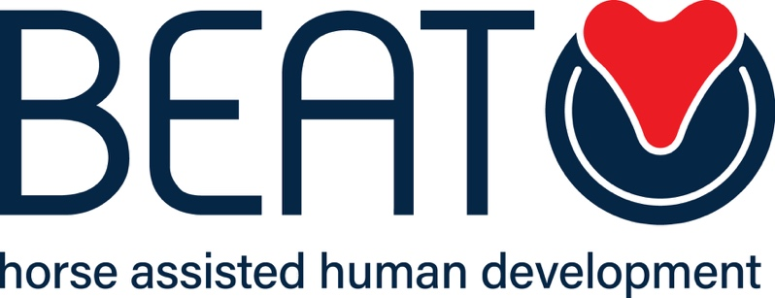

BEHAVIOUR POLICY

Name of Organisation: BEAT Limited
Venue/address for which policy applies: All venues Date of last review: 5th January 2022
Date of next review: 5th January 2023 Name of author: Claire Cole

This policy relates to the following documents and policies:

- Health and safety
- Equal opportunities

INTRODUCTION

Our behaviour policy supports our vision and values. BEAT Limited:

- Inspires and supports all clients
- Cares and values all clients
- Provides opportunities for all
- Puts the emotional health and well-being of clients first
- Expects clients to work hard and to their full potential

Our primary focus is on developing and building on positive relationships which create an environment that allows clients to engage fully in their Equine Assisted process. In order to ensure success for all we have in place a range of interventions to support clients. We aim to promote good behaviour and deter bad behaviour including all forms of bullying. We communicate on an on-going basis with any and all stakeholders with regard to our behaviour policy and procedures and when formally reviewing this policy which is then published on our website.

BEING CONSISTENT

Behaviour and Learning is everyone’s responsibility. We will be more successful in maintaining positive and respectful behaviour if we are consistent in our approach and if we work as a team.

All adults will:
- model and reinforce positive behaviours
- have high expectations of behaviour
- challenge inappropriate/negative behaviour
- actively seek to praise clients appropriately
- calmly apply and follow up consequences

Clients will be given unconditional positive acceptance, - making clear to them that it is their behaviour that is unacceptable, not them as a person.

Racism, sexism and discrimination and bullying of any kind, towards people or animals, will not be tolerated.

Incidences of unacceptable behaviour will be recorded and issues dealt with in line with BEAT Limited policies and procedures. BEAT Limited continues to develop protocols to provide guidance and support staff to staff in dealing with a range of situations/circumstances. For example
– dealing with drug related incidents; bullying; violent behaviour being exhibited. These will be regularly reviewed and updated.

Consequences

- All consequences should have a learning focus, build relationships and encourage clients to take responsibility
- Restorative approaches are encouraged and supported
- Consequences do not have to be heavy to be effective, but must always be followed through as agreed and dealt with consistently.
- Once a consequence has been agreed and implemented, clients will be helped to experience a fresh start. The criticism of a client’s unacceptable behaviour will be given privately and not in front of others.
- All staff will follow the agreed procedures to log incidents and inform parents/referrers. This data will be monitored regularly.
- In the event of a very serious incident staff will contact the Manager/Directors immediately. All such incidents will be thoroughly investigated and written accounts will be recorded by all parties involved independently.

Occasionally as a consequence of significant or repeated behavioural incidents a review of their programme will be required. This will be in consultation with clients and will be a short or medium term response which will be regularly reviewed.

BEAT Limited (Company Number (64541) Registered Office: Clifton Lodge, Vale, Guernsey, GY3 5DT

